PROJECT REPORT
EXAMPRO
ONLINE EXAMINATION SYSTEM
A Web-Based Platform for Digital Examination Management

SUBMITTED BY
S. No. | Name of Student | Register Number
1 | POLARPU THARUN | 99230040897
2 | PAGADI NITHYA SREE | 99230040703
3 | BARAPANEDI AKSHITHA | 99230041274
4 | KOLLAMORAM RAJESH | 99230040615
5 | ANGADI MANJUNATH | 99230040474
6 | YELLURI HARSHITH | 99230040462

PROJECT DOMAIN: MERN STACK WEB DEVELOPMENT
Academic Project Documentation

ABSTRACT
ExamPro is a web-based Online Examination System designed to provide a digital platform for examination-related activities. The project aims to simplify the interaction between students and administrators by presenting role-oriented pages for accessing examination information and managing examination activities.
The application is planned around two primary roles: Student and Admin. Students are intended to register, log in, view available examinations, attend examinations and review their results. Administrators are intended to manage student information, examinations, questions and results. The system is designed to reduce dependence on manual examination coordination and provide a structured digital workflow.
The current implementation is a frontend prototype developed using React.js and Vite. It includes the home page, login and registration interfaces, React Router navigation, protected routes, a student dashboard and demo authentication state managed through React Context and localStorage. Dashboard content currently uses mock data. The initial admin dashboard is under development.
The planned full-stack architecture uses Node.js and Express.js to implement backend services and REST APIs, MongoDB to persist application data, and Mongoose to model database records. Axios is intended to connect the React frontend with backend endpoints. Server-side authentication, secure password hashing, examination delivery, result calculation and persistent database integration are future implementation tasks; they are not represented as completed functionality in this report.
This report documents the project motivation, requirements, proposed design, current frontend implementation, planned backend design, testing approach, current results and future enhancements.

TABLE OF CONTENTS
Section | Page
ABSTRACT | i
CHAPTER 1 – INTRODUCTION | 1
1.1 Introduction | 1
1.2 Problem Statement | 2
1.3 Objectives | 2
1.4 Scope | 3
CHAPTER 2 – SYSTEM ANALYSIS | 4
2.1 Existing System | 4
2.2 Limitations | 4
2.3 Proposed System | 5
2.4 Functional Requirements | 5
2.5 Non-Functional Requirements | 6
2.6 Feasibility Study | 7
CHAPTER 3 – SYSTEM DESIGN | 8
3.1 Architecture | 8
3.2 Workflow | 9
3.3 Proposed Database Design | 10
3.4 Module Design | 11
3.5 Security Design | 12
CHAPTER 4 – SYSTEM IMPLEMENTATION | 13
4.1 Frontend Implementation | 13
4.2 Routing and Authentication Prototype | 14
4.3 Backend and API Plan | 15
4.4 Database Plan | 16
CHAPTER 5 – SYSTEM TESTING | 17
CHAPTER 6 – RESULTS AND DISCUSSION | 19
CHAPTER 7 – CONCLUSION AND FUTURE ENHANCEMENTS | 21
REFERENCES | 23

Note: Page numbers are indicative. Update the table of contents after final formatting or after adding actual application screenshots.

CHAPTER 1 – INTRODUCTION

1.1 Introduction
Digital technologies are increasingly used to deliver services that were traditionally handled through paper-based processes. Education is one such area where web applications can support communication, record management and assessment activities. An Online Examination System provides a central interface through which examination information and related tasks can be organised.
ExamPro is proposed as a web application with separate Student and Admin experiences. The Student interface focuses on accessing examination information and tracking academic performance. The Admin interface is intended to support the management of students, examinations, questions and results.

1.2 Problem Statement
Traditional examination workflows may involve manual preparation of question papers, physical distribution, paper-based answer collection, manual evaluation and separate result records. These activities can require considerable coordination and may delay the communication of results. A digital platform can help organise these activities and provide a consistent user experience.

1.3 Objectives of the Project
- Develop a user-friendly web interface for an online examination platform.
- Provide separate navigation experiences for students and administrators.
- Allow students to access examination information through a dashboard.
- Provide an administrative foundation for managing students, exams, questions and results.
- Design a modular architecture that can be extended with backend APIs and database services.
- Plan a secure full-stack implementation with server-side authentication and persistent storage.

1.4 Scope of the Project
The current scope covers the frontend prototype: project setup, page navigation, login and registration interfaces, demo authentication state, protected routes and a student dashboard using sample data. The planned scope includes backend APIs, database integration, examination delivery, timed assessments, answer submission, score calculation and administrative management. These planned functions will be implemented and tested in later development phases.

CHAPTER 2 – SYSTEM ANALYSIS

2.1 Analysis of the Existing System
In a conventional examination process, administrators may prepare and distribute question papers, supervise examinations, collect answer scripts, evaluate responses and publish results. Records may be maintained across paper documents or separate digital files. The exact process varies by institution.

2.2 Limitations of the Existing System
- Manual coordination can increase administrative workload.
- Paper-based activities consume physical resources.
- Result preparation and publication may take time.
- Examination information may be distributed across multiple records.
- Students may have limited access to a consolidated view of their examination history.

2.3 Proposed System
ExamPro proposes a central web interface for student and administrator activities. The student module is designed to provide account access, dashboard information and examination-related navigation. The admin module is intended to provide management functions for student records, exams, questions and results. A future backend will provide APIs and persistent data storage.

2.4 Functional Requirements
ID | Requirement | Status
FR-01 | Display the application home page. | Implemented
FR-02 | Provide login and registration interfaces. | Implemented UI
FR-03 | Maintain demo login state using React Context/localStorage. | Implemented prototype
FR-04 | Restrict student and admin frontend routes by role. | Implemented prototype
FR-05 | Display student dashboard information and sample exams. | Implemented with mock data
FR-06 | Admin management of students, exams and questions. | Planned / in progress
FR-07 | Create and store exams through backend APIs. | Planned
FR-08 | Submit answers and calculate examination results. | Planned
FR-09 | Persist users, exams, questions and results in MongoDB. | Planned

2.5 Non-Functional Requirements
- Usability: pages should be clear and easy to navigate.
- Maintainability: components and modules should be organised for easier updates.
- Performance: pages and API operations should respond within reasonable time under expected usage.
- Security: production authentication and authorization must be enforced on the server.
- Reliability: examination submissions and results should be stored consistently after backend implementation.
- Compatibility: the interface should support modern web browsers and common screen sizes.

2.6 Hardware Requirements
Component | Suggested minimum requirement
Processor | Dual-core processor or equivalent
RAM | 4 GB or higher
Storage | At least 2 GB free space for development tools and project files
Display | 1366 × 768 resolution or higher
Network | Internet connection for package installation and deployment

2.7 Software Requirements
Software | Purpose
Windows / Linux / macOS | Development operating system
Visual Studio Code | Code editor
Node.js and npm | JavaScript runtime and package management
React.js and Vite | Frontend development
React Router DOM | Client-side navigation
Bootstrap 5 and CSS | Interface styling
Node.js and Express.js | Planned backend and REST API development
MongoDB and Mongoose | Planned data storage and modelling
Axios | Planned frontend API communication

2.8 Feasibility Study
Technical feasibility: The selected technologies are widely used for web application development. The current frontend prototype has been created using React and Vite. The backend and database components are technically feasible but remain to be implemented.
Operational feasibility: The two-role design is intended to provide a familiar workflow for students and administrators. Usability should be validated with representative users during later testing.
Economic feasibility: The project uses commonly available development tools and open-source technologies. Hosting, database deployment and maintenance costs will depend on the final deployment choice.

CHAPTER 3 – SYSTEM DESIGN

3.1 System Architecture
The proposed system follows a client-server architecture. The React frontend presents the user interface. The frontend will send HTTP requests to REST API endpoints. Express.js, running on Node.js, will process those requests and interact with MongoDB through Mongoose. The backend will return responses that the frontend can display.
Layer | Technology | Responsibility | Current status
Presentation | React.js, Vite, Bootstrap, CSS | Pages, components and user interaction | Implemented prototype
Routing | React Router DOM | Navigate between public and protected pages | Implemented prototype
API communication | Axios / REST | Send requests and receive responses | Planned
Application server | Node.js, Express.js | Routes, controllers and business logic | Planned
Data layer | MongoDB, Mongoose | Persist and retrieve application records | Planned

3.2 System Workflow
- A user opens the ExamPro web application.
- The user selects the appropriate login or registration page.
- The current prototype updates authentication state using demo frontend logic.
- Protected routes check the user role before displaying the corresponding dashboard.
- In the planned full-stack version, the frontend will call backend APIs for authentication and examination data.
- The backend will validate requests, access MongoDB and return a response to the frontend.

3.3 Proposed Database Design
The following collections are proposed for the future MongoDB implementation. They describe the planned data model and are not yet connected to the current frontend prototype.
Collection | Example fields | Purpose
Users | _id, name, email, passwordHash, role, createdAt | Store student and admin account records
Exams | _id, title, description, duration, startDate, endDate, status | Store examination details
Questions | _id, examId, questionText, options, correctAnswer, marks | Store questions associated with an exam
Results | _id, studentId, examId, score, totalMarks, submittedAt | Store submitted examination outcomes

3.4 Module Design

Student Module
The student module is intended to support registration, login, dashboard access, viewing available exams, attending an exam and reviewing results. The current dashboard displays sample examination cards, summary statistics and recent result information using mock data.

Admin Module
The admin module is intended to support student management, exam creation, question management and result review. An initial admin dashboard layout has been prepared; the management workflows and backend operations are not yet complete.

3.5 Security Design
The current prototype uses frontend role checks for demonstration. These checks are not sufficient for production security because browser-side state can be modified by a user. The planned backend must validate credentials, hash passwords using a suitable password-hashing library such as bcrypt, issue and verify authentication tokens such as JWT, enforce role-based authorization on protected API endpoints, validate input and avoid exposing correct answers before an exam is submitted.

CHAPTER 4 – SYSTEM IMPLEMENTATION

4.1 Introduction
Implementation is being carried out in phases. The first phase establishes the frontend structure and navigation. The next phase will introduce backend services, REST APIs and database integration.

4.2 Frontend Implementation
The frontend was scaffolded using Vite with React. React components are used to organise reusable interface elements, while page components represent the main application screens. Bootstrap and custom CSS provide layout and styling.
Frontend element | Purpose / implementation
Home page | Introduces the ExamPro application.
Login page | Collects demo user credentials in the current prototype.
Register page | Provides the registration interface.
AuthContext | Shares authentication state and login/logout functions across components.
ProtectedRoute | Checks demo login state and role before rendering protected pages.
Student Dashboard | Displays welcome information, statistics, sample exams and recent results.
Admin Dashboard | Initial administrative dashboard layout; further features remain in progress.

4.3 Routing and Authentication Prototype
React Router DOM is used to navigate between the home, login, registration and dashboard routes. ProtectedRoute checks whether a user is logged in and whether the user's role is allowed to access a route. The current authentication flow is a frontend demonstration using React Context and localStorage; it does not perform server-side credential verification.
Example route design:
Public routes: /, /login, /register\nStudent route: /student/dashboard\nAdmin route: /admin/dashboard

4.4 Backend and API Plan
The backend is planned as a separate application using Node.js and Express.js. Routes will define API endpoints, controllers will process requests, models will describe database records and server.js will configure middleware and start the server.
Planned endpoint | Method | Purpose
/api/auth/register | POST | Register a new user
/api/auth/login | POST | Authenticate a user
/api/exams | GET | Retrieve available examinations
/api/exams | POST | Create an examination (admin)
/api/exams/:id/questions | GET | Retrieve questions for an examination
/api/results | GET | Retrieve results for the authenticated student
/api/results | POST | Submit and store an examination result

These endpoints are proposed examples. They are not currently deployed or callable in the project.

4.5 Database Implementation Plan
MongoDB will be used as the planned database. Mongoose schemas will define the structure and validation rules for user, exam, question and result documents. The backend will use these models to create, read, update and delete records. Database connection configuration and environment variables will be added during backend development.

4.6 Planned Examination Workflow
- Admin creates an exam and adds questions.
- Student views the list of published exams.
- Student opens exam instructions and starts the assessment.
- The application displays questions and a countdown timer.
- Student submits answers before the allowed time ends.
- Backend evaluates objective answers and calculates the score.
- Result is saved and made available to the student and authorized admin.

CHAPTER 5 – SYSTEM TESTING

5.1 Introduction
Testing is required to verify that the implemented frontend behaves as expected and that future backend services meet their functional and security requirements. The test cases below distinguish checks applicable to the current prototype from tests that must be performed after backend implementation.

5.2 Types of Testing
- UI testing: verify that pages and interface elements render correctly.
- Navigation testing: verify that links and routes open the intended pages.
- Role access testing: verify that student and admin demo routes are separated.
- Integration testing: planned testing of React, API endpoints and MongoDB.
- Security testing: planned validation of authentication, authorization and input handling.
- Usability testing: review clarity and ease of use with representative users.

5.3 Test Cases
Test ID | Test scenario | Expected result | Status
TC-01 | Open the home page | Home page is displayed | Prototype implemented
TC-02 | Open login page | Login interface is displayed | Prototype implemented
TC-03 | Open registration page | Registration interface is displayed | Prototype implemented
TC-04 | Login using demo student credentials | Student dashboard opens | Prototype implemented
TC-05 | Access student route without login | User is redirected to login | Prototype route guard
TC-06 | Access admin route with student role | Access is restricted / redirected | Prototype route guard
TC-07 | Retrieve exams from API | Exam data is returned from backend | Pending
TC-08 | Save a new exam to MongoDB | Exam record is stored | Pending
TC-09 | Submit answers and calculate score | Result is calculated and stored | Pending

5.4 Testing Result
The current frontend prototype has been exercised for page rendering, navigation and demo role-based access. The student dashboard displays mock content. End-to-end testing of backend APIs, database persistence, examination submission and result calculation cannot be reported until those components are implemented.

CHAPTER 6 – RESULTS AND DISCUSSION

6.1 Introduction
The current project result is a working frontend foundation for ExamPro. The application structure supports public pages and role-specific dashboard routes. The student dashboard demonstrates how examination information and summary statistics can be presented.

6.2 Home, Login and Registration Interfaces
The home page introduces the platform, while the login and registration pages provide the initial user entry points. These interfaces form the base for later integration with backend authentication APIs.

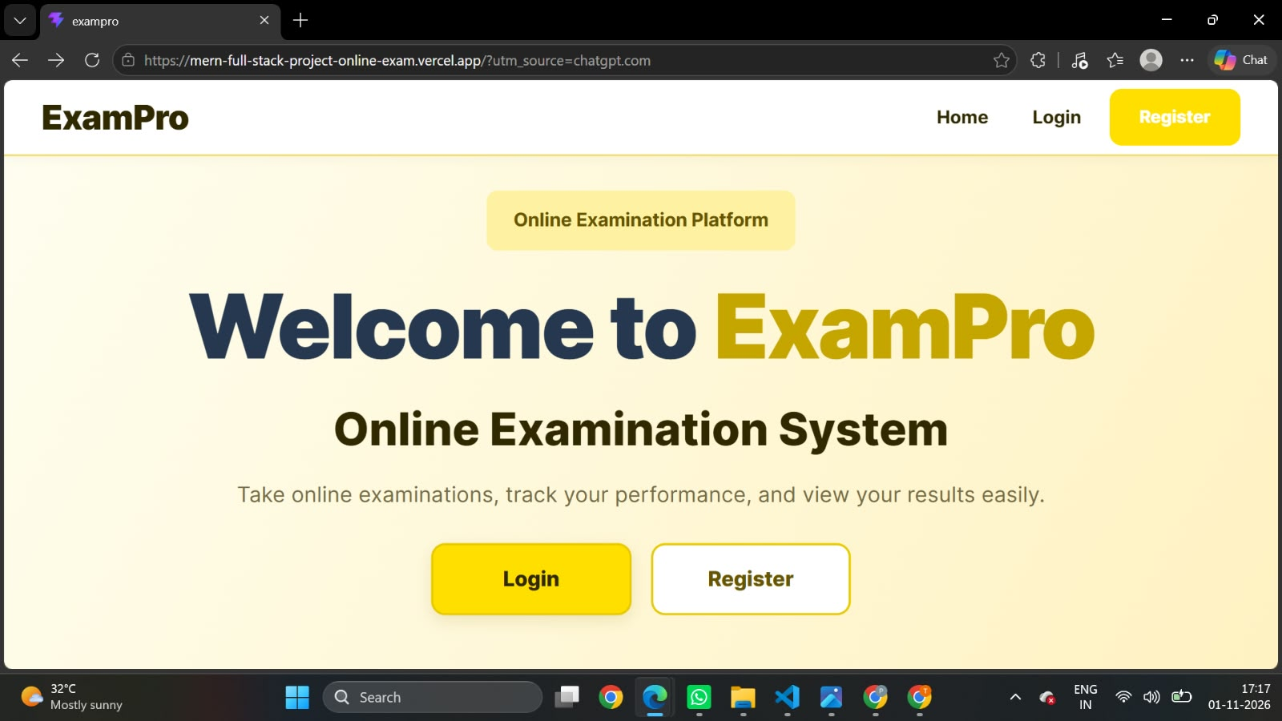
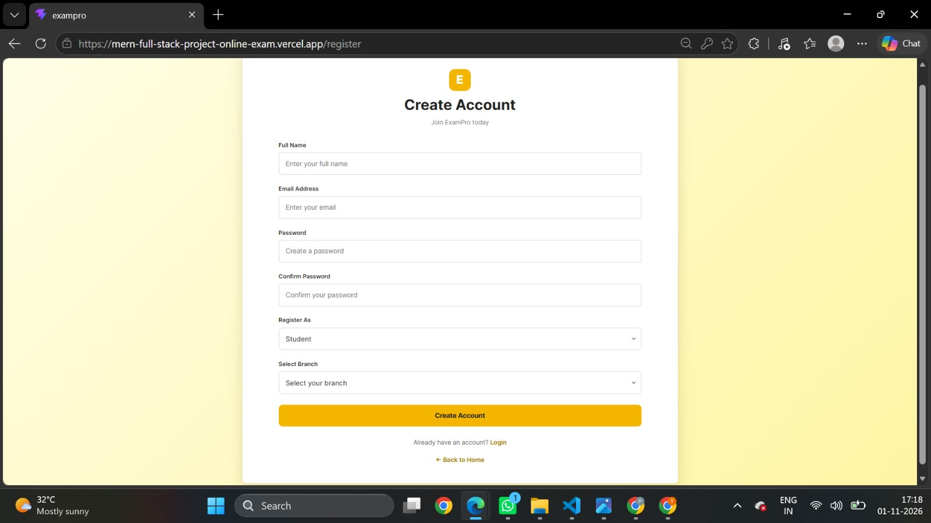

6.3 Student Dashboard
The student dashboard displays a welcome section, summary statistics, sample available examinations, recent results and profile-related information. The displayed content is mock data intended to demonstrate the user interface.
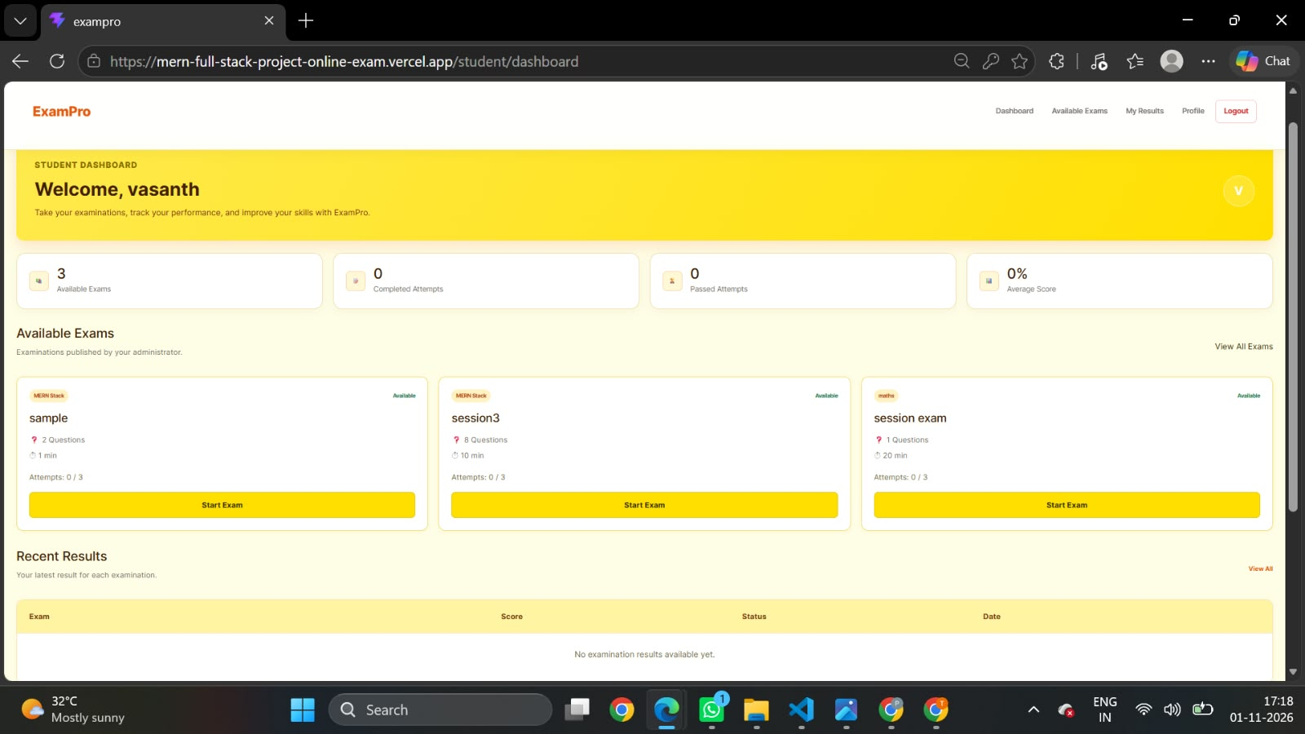

6.4 Admin Dashboard
An initial admin dashboard layout has been designed to represent administrative actions such as managing students, examinations, questions and results. The complete management operations remain under development.
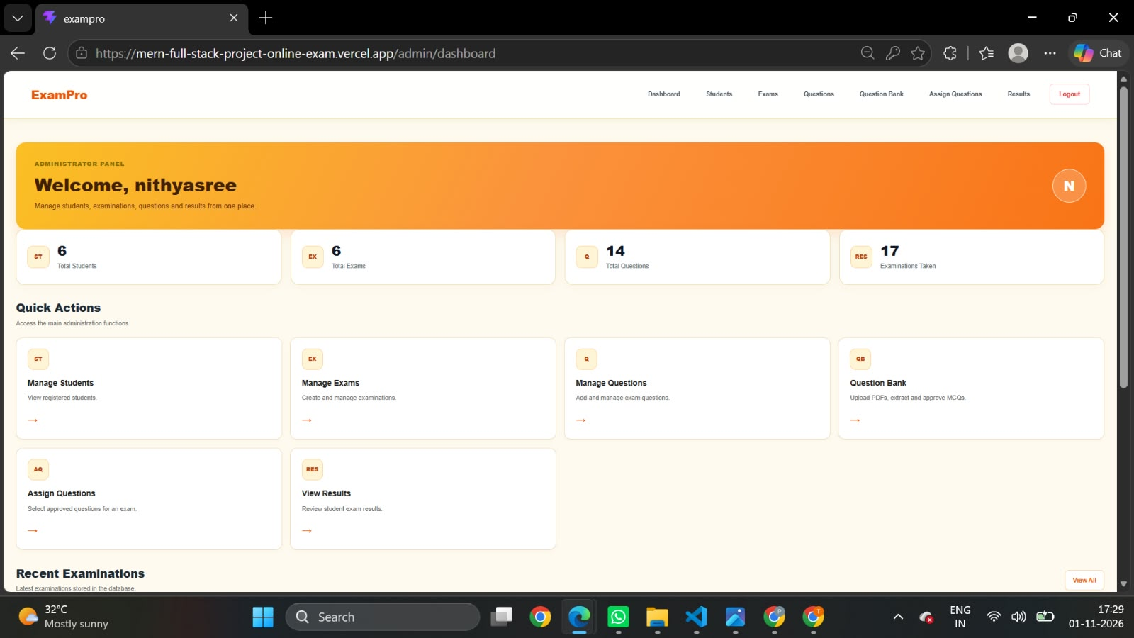

6.5 Overall Result
The current outcome demonstrates the frontend navigation and dashboard concept. The application is not yet a complete end-to-end MERN system because the backend APIs, MongoDB integration and full examination workflow remain planned work.

CHAPTER 7 – CONCLUSION AND FUTURE ENHANCEMENTS

7.1 Conclusion
ExamPro is a proposed Online Examination System intended to organise examination activities through a web-based platform for students and administrators. The current development phase has established the React and Vite frontend, home page, login and registration interfaces, demo authentication, protected routes and a student dashboard using mock data. An initial admin dashboard is also being developed.
The project provides a foundation for the next phase of full-stack implementation. Backend APIs, MongoDB persistence, secure authentication, exam delivery and result processing must be completed before the system can be considered a fully functional online examination platform.

7.2 Future Enhancements
- Develop Node.js and Express.js backend services.
- Create REST APIs for authentication, exams, questions and results.
- Integrate MongoDB using Mongoose models.
- Implement server-side authentication with password hashing and token validation.
- Build admin workflows for student, exam and question management.
- Implement exam instructions, countdown timer, answer saving and submission.
- Add automatic evaluation for objective questions and result history.
- Add audit logs, exam scheduling, notifications and reporting.
- Deploy the application with secure configuration, monitoring and backups.

7.3 Final Summary
The project is being developed incrementally. The current frontend prototype demonstrates the user interface and navigation concept, while the planned backend phase will add data persistence and real examination functionality. All future functionality should be validated through integration, security and usability testing.

REFERENCES
- React Documentation. https://react.dev/
- Vite Documentation. https://vite.dev/
- React Router Documentation. https://reactrouter.com/
- Bootstrap Documentation. https://getbootstrap.com/docs/
- Node.js Documentation. https://nodejs.org/docs/
- Express.js Documentation. https://expressjs.com/
- MongoDB Documentation. https://www.mongodb.com/docs/
- Mongoose Documentation. https://mongoosejs.com/docs/
- Axios Documentation. https://axios-http.com/docs/intro

